**Gym Management System**

# Introduction

This document describes the requirements and design details of a gym management system which will store data about members and their memberships, employees, gym equipment etc.

# Requirements

Provide separate login panels for admin, receptionist and trainers.

## Admin Requirements

1. Admin should be able to add/update/delete a trainer/receptionist/admin.
2. Admin should be able to add/update/delete gym equipment.
3. Admin should be able to create membership plans.
4. Admin should be able to assign/un-assign trainer to a gym member.

## Receptionist Requirements

1. Receptionist should be able to register/modify/deregister a gym member.
2. Receptionist should be able to generate a receipt

## Trainer Requirements

1. Trainer should be able to take measurements of the member.
2. Trainer should be able to view all its assigned members and track their individual progress.

# ER Diagram

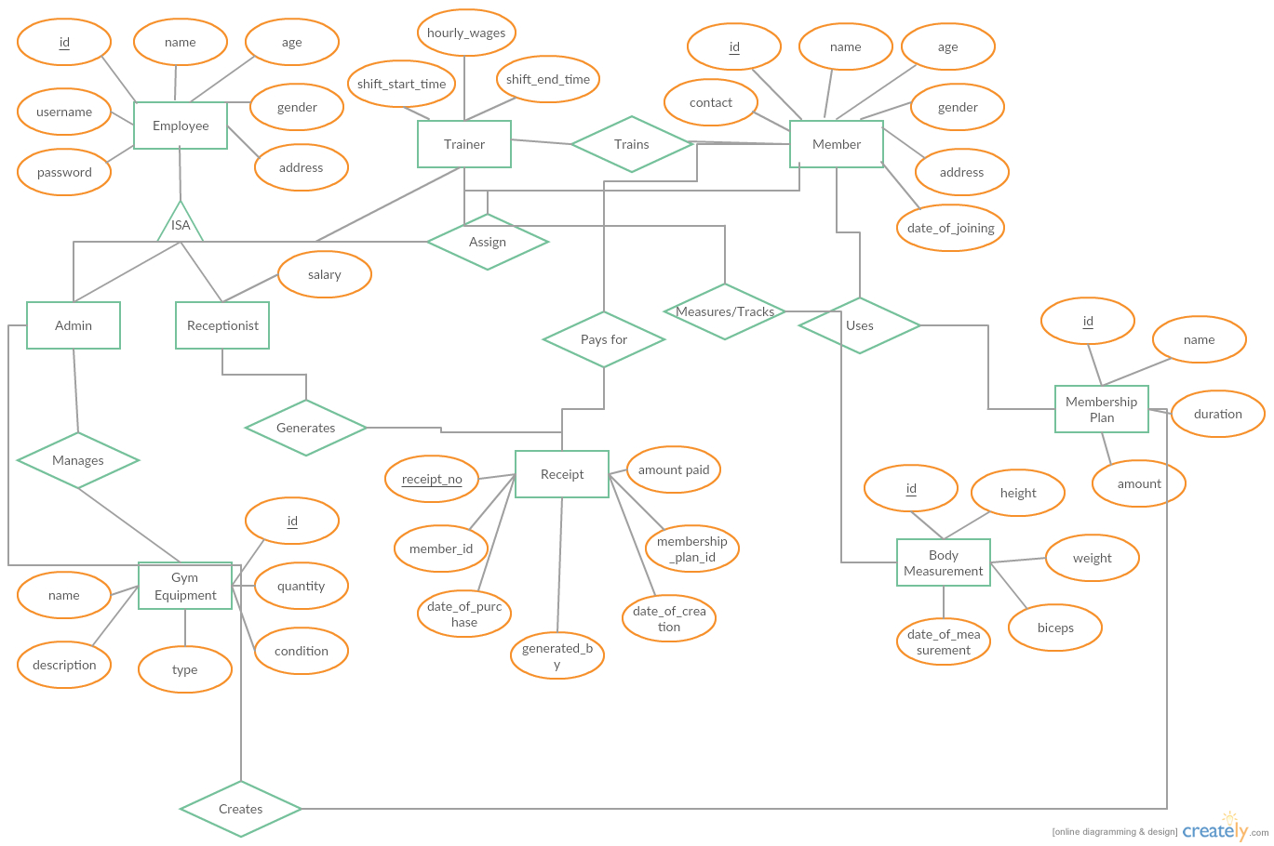

# Database Diagram

